**DAILY ASSESSMENT FORMAT**

|  |  |  |  |
| --- | --- | --- | --- |
| **Date:** | **19/05/2020** | **Name:** | **Nithyashree S** |
| **Course:** | **TCS iON** | **USN:** | **4AL18EC036** |
| **Topic:** | **1.Career guidance**  **2.Writting resume and cover letter**  **3.Group discussion** | **Semester & Section:** | **3rd Sem**  **‘A’ Section** |
| **Github Repository:** | **Nithyashree-S** |  |  |

|  |
| --- |
| **FORENOON SESSION** |
| **Image of the session** |

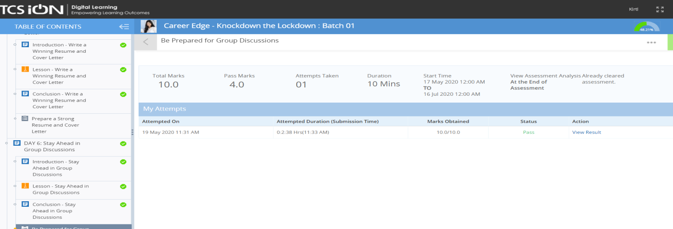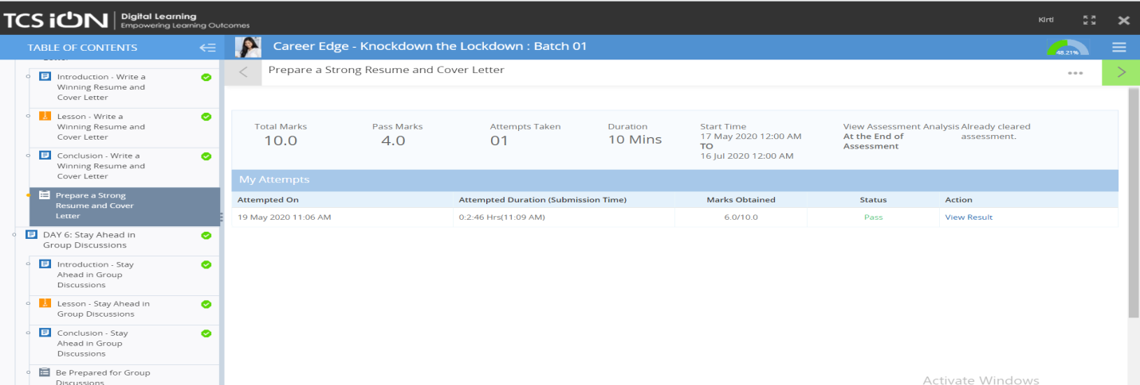

|  |
| --- |
| **REPORT**  **Topics learnt,**   * **Guidance from career gurus** * **Need of Headstart** * **6 pillars of Headstart** * **Writing a strong resume and cover letter** * **Structure of resume** * **Do’s & Don’ts of resume writing** * **Contents of a cover letter** * **Do’s & Don’ts of cover letter** * **Staying ahead in group discussion** * **Introduction to group discussion** * **Format of a group discussion** * **Do’s & Don’ts** * **Mock group discussion & its case study** |

|  |
| --- |
| **AFTERNOON SESSION** |

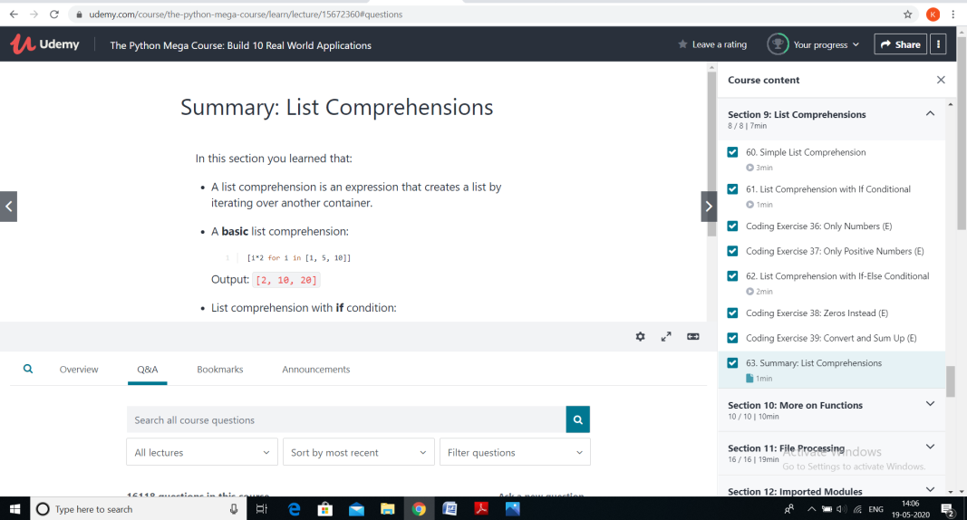

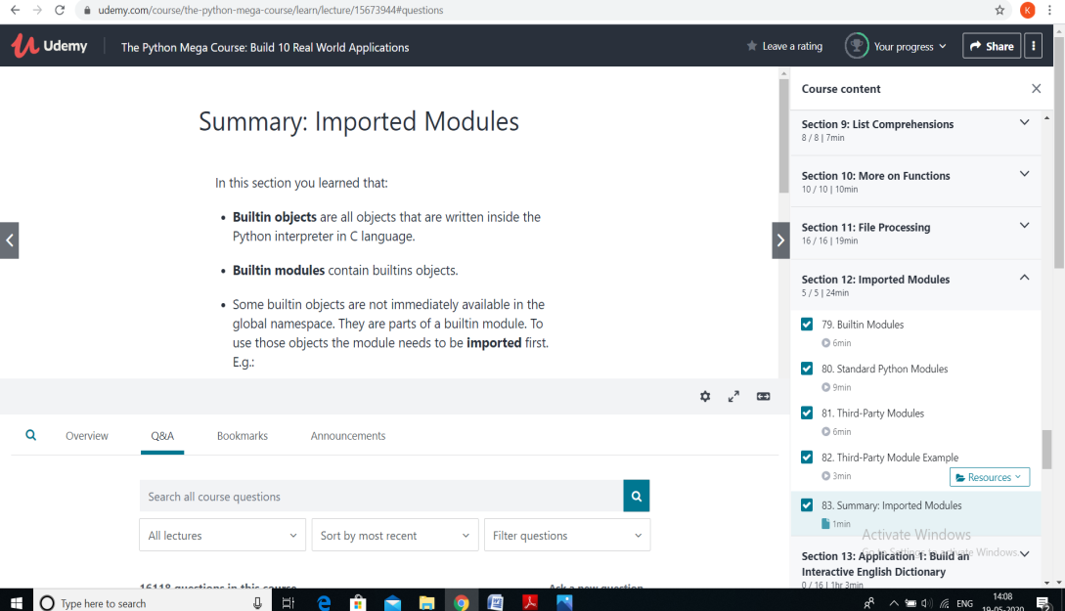

|  |
| --- |
| **Topics covered**   * **List Comprehensions** * **List comprehensions with if condtional & its coding exercises** * **List comprehensions with if if-else conditional & its coding exercises** * **Functions** * **Functions with multiple arguments & its coding exercises** * **Default and Non-default arguments & its coding exercises** * **File processing** * **Concept of processing files in phython** * **Different filepaths & coding exercises** * **Import modules** * **Builtin modules** * **Standard phython modules** * **Third party modules & examples** |